* Mehanical Maps [header Part]

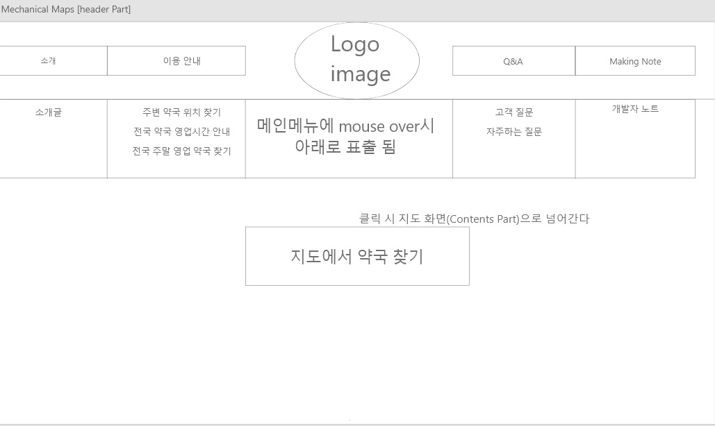

* Mehanical Maps [content Part 1]

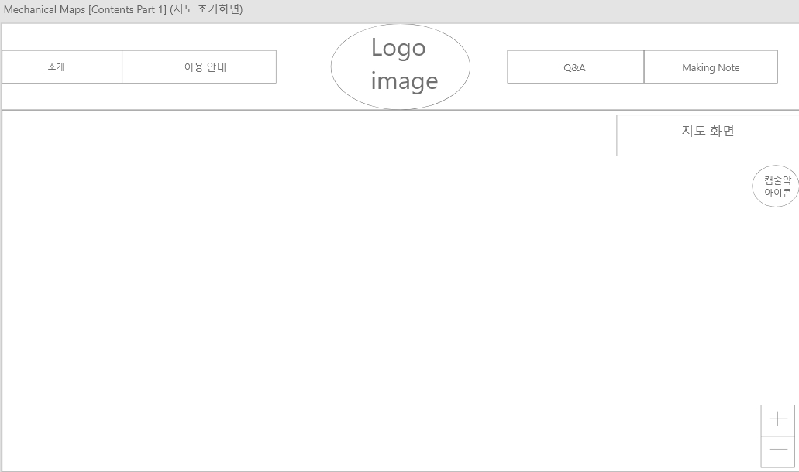

* Mehanical Maps [content Part 2]

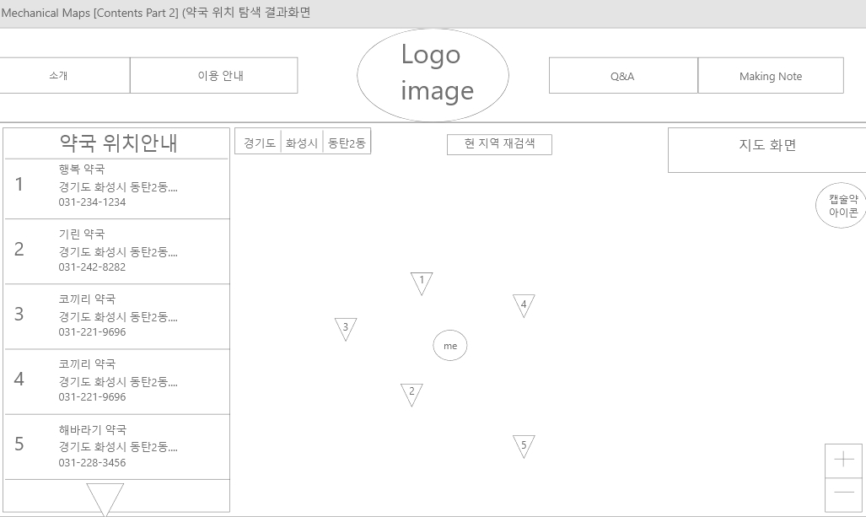

* Mehanical Maps [footer Part 1]

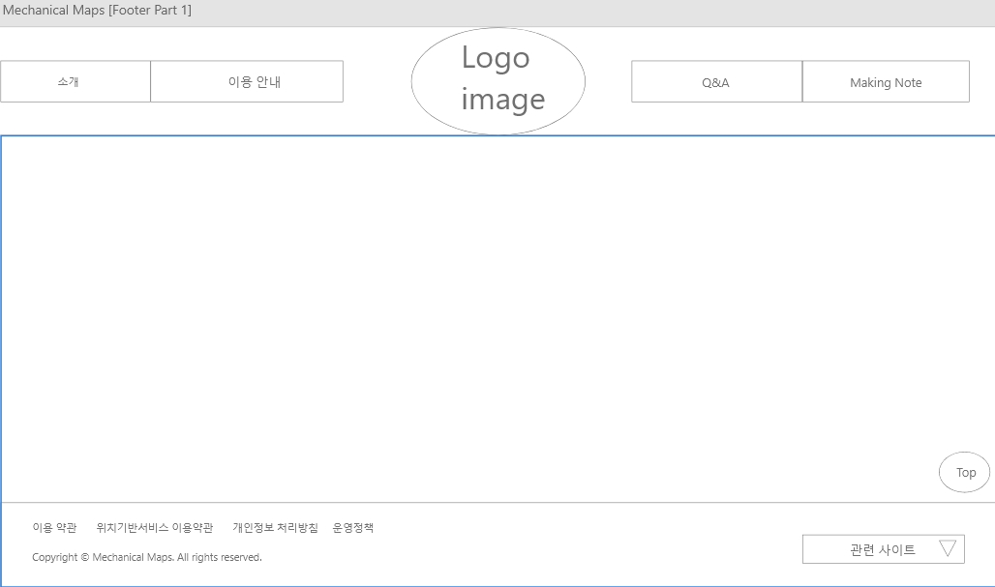

* Mehanical Maps [footer Part 2]

